**ICU Monitor**

**Advanced Embedded systems**

**By:**

Omnya Ahmed Mohamed Ellethy

1180213

**Submitted to:**

DR. Amr Ali

ENG. Muhammed Mustafa

# **System Block diagram**



# **Task description**

In this project, we built a heart rate monitoring system, using Arduino, that counts heartbeats in a minute. The system starts measure the heartbeat once the finger is placed on the sensor.

Working of this project is quite easy but a little calculation for calculating heart rate is required. There are several methods for calculating heart rate, but here we have read only ten pulses. Then we have calculated total heartbeat in a minute by applying the below formula:

# In this project we read the heart rate of only ten pulses calculating total heartbeat in a minute

After getting ten pulses we again take counter value in time2 and then

* we subtract time1 from time2 to take original time taken by five pulses.

And then divide this time by 10 times for getting single pulse time.

Now we have time for single pulse, and we can easily find the pulse in one minute, dividing 600000 ms(60s) by single pulse time.

* + After we get the calculated heart rate (BPM), we make checking conditions on the output value if it was in the heart normal range or in an abnormal range **60 to 100 beats per minute** or we check for the functionality by smaller values we can obtain during test

# Deep dive

## Diagram Description automatically generated with medium confidencePulse Sensor

The Pulse Sensor that we make is essentially a photoplethysmography **PPG**

* medical device used for non-invasive heart rate monitoring.

Pulse Sensor Amped responds to relative changes in light intensity.

### Light intensity role

When the heartbeat into blood arteries it inflates artery respectively so it can reflect the green light emitted from the sensor led

Lighter and the signal goes up. Less light, the opposite. Light from the green LED that is reflected back to the sensor changes during each pulse.

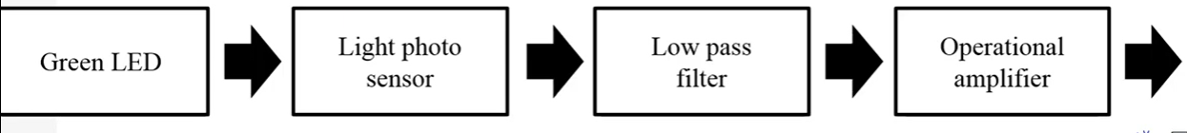

### Heart rate calculation

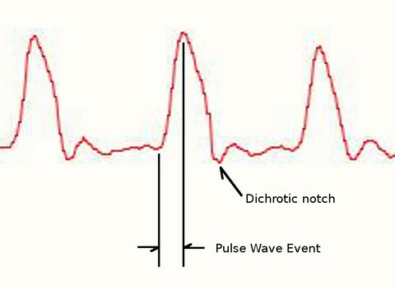The heart pulse signal that comes out of a photoplethysmography is an analog fluctuation in voltage, with a predictable wave shape

If the amount of light incident on the sensor remains constant, the signal value will remain at 512 (midpoint of ADC range) automatically read until pulse wave event occur

But the dichroitic notch cause irregular reading so we can’t measure with the regular pulse peak difference.

Usually, we calculate using averaging where the pulse is expected to occur since normal range is repeatable throughout the signal so it can easily be predicted.

### Chart Description automatically generatedMeasurements

successive moments of instantaneous heartbeat and measure the time between

* Inter Beat Interval (IBI)

By following the predictable shape and pattern of the PPG wave, we are able to do just that

However, pulse Sensor code is designed to measure the IBI by timing between moments when the signal crosses 50% of the wave amplitude during that fast upward rise.

The BPM is derived every beat from an average of the previous 10 IBI times

# **Unit testing**

|  |  |  |
| --- | --- | --- |
| **Led module functions** | **Inputs** | Partitions and **validation** |
| **Led init** | Port  Pin  direction | **Port**   * B * C * D   **Pin**   1. according to port   **Direction**   1. OUTPUT: valid 2. INPUT: invalid |
| **Led ON** | Port  Pin  state | **Port**   * B * C * D   **Pin**  **State**   * 1: valid * 0: invalid |
| **Led OFF** | Port  Pin  state | **Port**   * B * C * D   **Pin**  **State**   * 0: valid * 1: invalid |

|  |  |  |
| --- | --- | --- |
| **Buzzer module functions** | **inputs** | **Partitions and validation** |
| **Buzzer init** | Port  Pin  direction | **Port**   * B * C * D   **Pin**   1. according to port   **Direction**   1. OUTPUT: valid 2. INPUT: invalid |
| **Buzzer ON** | Port  Pin  state | **Port**   * B * C * D   **Pin**  **State**   * 1: valid * 0: invalid |
| **Buzzer OFF** | Port  Pin  state | **Port**   * B * C * D   **Pin**  **State**   * 0: valid * 1: invalid |

# **Time analysis**

Total time of the system 900 msec

|  |  |
| --- | --- |
| **functions** | **Time in msec** |
| Lcd_init | 4 msec |
| Interrupt | 2 msec |
| HBR_set | 2 msec |
| Led_set | 1 msec |

# **Working simulation**

